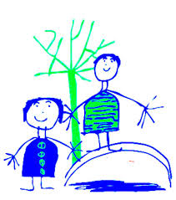
Dobcroft Infant School
“Reading at Home” challenges!
Try and tick off as many reading challenges as you can over the half-term holiday week at home – how many can you complete?

Read a book about animals – fiction or non-fiction | Draw a picture of your favourite character or story | Wrap up warm and read outside | Ask someone to read to you | Recommend a book to someone
Make a bookmark | Read a poem – can you also learn it off by heart and perform it? | Create a setting from a story – you could draw it, or build it in 3D with Lego or other materials | Read under a table | Read under a cosy blanket
Read inside a den you’ve made | Read to someone you don’t live with over video call | Read a magazine or comic | Read a story out loud using silly voices | Read a non-fiction book
Use toys or puppets to act out a story | Retell a story to someone who hasn’t read it before | Find out what your families’ favourite books are | Read in an unusual place | Read an adventure story

Please email any photos of your fantastic reading to Mrs Harrison at deputy@dobcroft-inf.sheffield.sch.uk, and let us know if you are happy for us to tweet your photos on our Twitter account @DobcroftInf too!
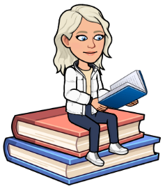
Have fun and happy reading,
Miss Hughes.

