Mrs Shepherd’s
Cooking Challenge

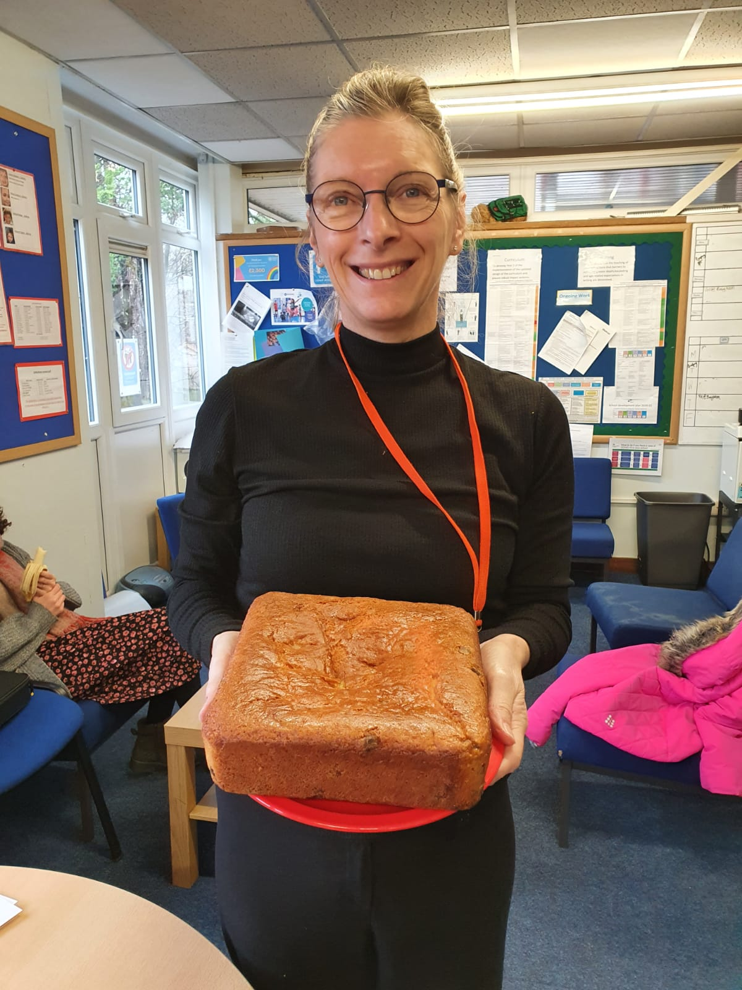

This week the challenge will be French Yogurt Cake (Gateau Au Yaourt). If you do make some of the cake please email pictures to enquiries@dobcroft-inf.sheffield.sch.uk. If you didn’t mind us putting the pictures on Twitter/school website then please let us know in the email. Leeeeet’s get cooking!

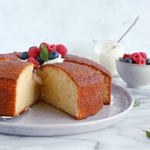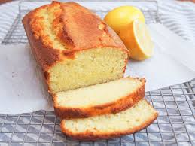

https://jessifearon.com/2019/09/french-yogurt-cake-a-k-a-the-easiest-recipe-to-make-with-your-kids.html

