Mrs Shepherd’s
Cooking Challenge

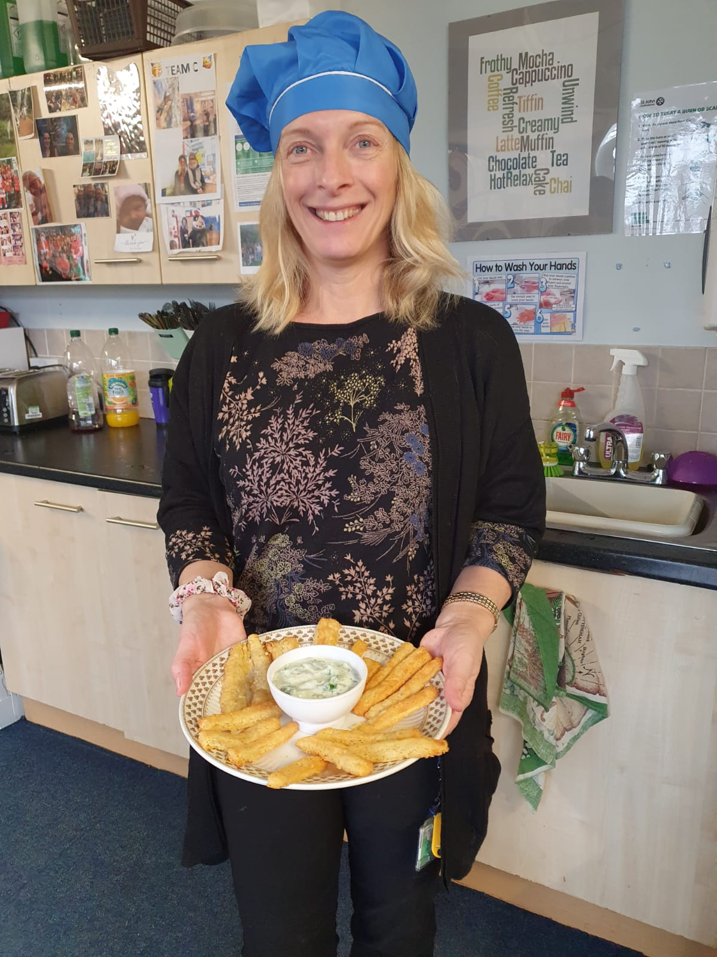

This week the challenge will be Easy Cheese Straws with dips. If you do make some of the cheese straws please email pictures to enquiries@dobcroft-inf.sheffield.sch.uk. If you didn’t mind us putting the pictures on Twitter/school website then please let us know in the email. Leeeeet’s get cooking!

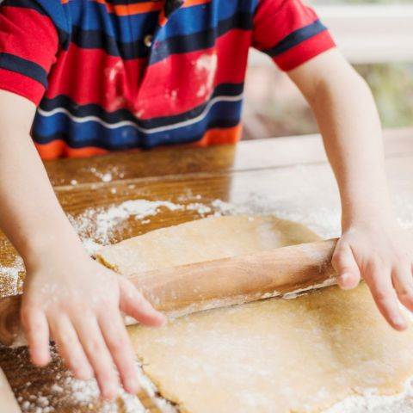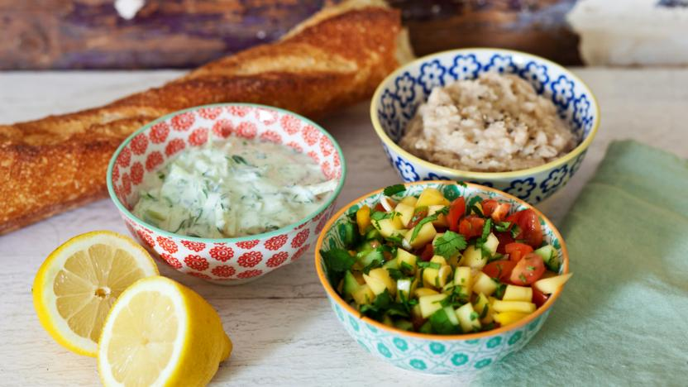

https://www.littledish.co.uk/advice-and-recipes/cheese-straws

https://www.bbc.co.uk/food/recipes/three_easy_dips_for_kids_08808

