Can label a penguin

I know facts about penguins

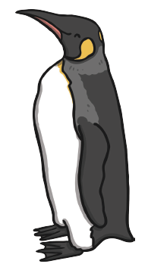

tail

feet

beak

feet