If you are looking for additional ways to support your child’s maths learning, please have a look at these free interactive games which we often play in class. The children love to learn using the class iPads, or by playing the games on our interactive whiteboard in the classroom, so we are sure that they will have great fun practising some of our key maths skills at home too!
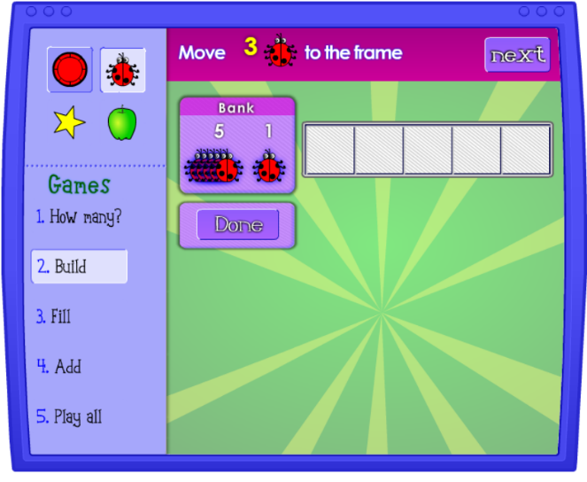
https://www.nctm.org/Classroom-Resources/Illuminations/Interactives/Five-Frame/
Select which object you would like to use. There are different game selections to choose from, though we begin with ‘Build’ to get the children used to counting out objects to match a numeral, before moving on to finding different ways to make 5, and working out how many more objects we need to fill the five frame and make 5.

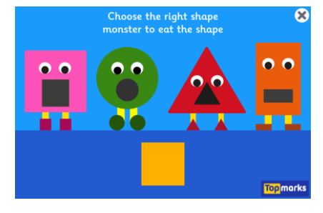
https://www.topmarks.co.uk/early-years/shape-monsters
Children are asked to match the shape at the bottom of the screen to the monster with the matching shaped mouth. As the monster eats the shape, it says the shape name. Encourage your child to repeat the shape name. When they are confidently recognising the shapes, you could begin to talk about the properties of each shape (sides, corners, straight, round, curved for example).

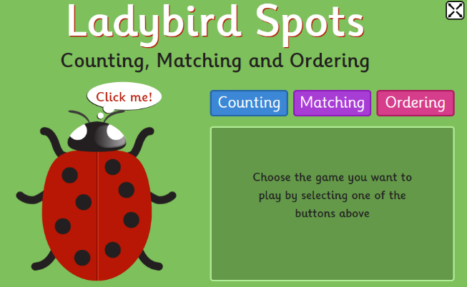
https://www.topmarks.co.uk/learning-to-count/ladybird-spots
Ladybird spots practises three key skills; number recognition, number ordering, and counting out a number of objects to match a given numeral. Children select the game that they want to play, and then count the spots accordingly.

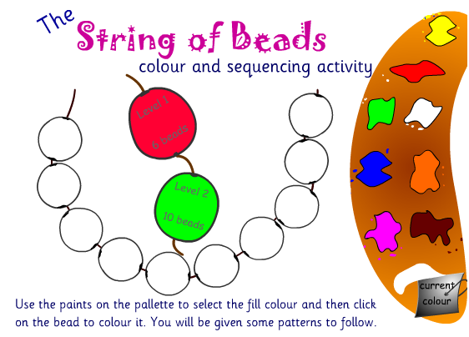
http://www.crickweb.co.uk/Early-Years.html
String of beads is a colour and pattern sequencing activity where children are given a colour sequence to copy on their own string of interactive beads. You could talk about whether or not the sequence is repeating or not repeating, and which colours it uses. You could also create your own patterns using beads and string to make a necklace or bracelet for yourself or a family member.

