Pingle Road
Sheffield, S7 2LN
Tel: 0114 2368099

School email: enquiries
@dobcroft-inf.sheffield.sch.uk

Website: www.dobcroft-inf.sheffield.sch.uk
Twitter: @DobcroftInf

Head teacher: Mrs Cathy Rowland,
headteacher@dobcroft-inf.sheffield.sch.uk

Deputy Head teacher: Mrs Vicky Harrison,
deputy@dobcroft-inf.sheffield.sch.uk

Chair of Governors: Andy Gates,
chair@dobcroft-inf.sheffield.sch.uk



Infant School

Dear Year 1 families

We are writing to you to keep you updated on our plans for remote learning for year 1 in the coming few weeks. As you can imagine, we are having to adapt rapidly to a changing situation. We will try to keep you as updated as we can throughout. Thank you in advance for all of your support.

Regarding home learning, each Friday we will upload the following weeks remote home learning to the gallery page on the website. We will also upload a suggested weekly timetable, which will mirror the learning in school, so if your child has any days in school you will know which lessons they have done. We will upload this in 3 separate posts which will be:
- Maths - 3 to 4 lessons, with some practical and some recorded lessons.
- English - 3 to 4 lessons, including a handwriting and literacy activities based around our book.
- Topic - for example 2 or 3 of the following; history, geography, art, PSHE, design technology, music, R.E. and P.E.
We will include videos of us talking through some of the lessons for your child. Some lessons may also be learning from Oak Academy or BBC bitesize. Please feel free to explore these resources if you wish to use this for your learning. We have uploaded our knowledge organiser for this half term which gives you an outline of what we will be covering. Our topic this term is Ice and Fire. This half term we will be learning about the Titanic and reading The Great Explorer by Chris Judge. There will be two design technology projects this half term; to build a model of the Titanic and to build an Arctic scene as a stimulus for writing. You may wish to start collecting some items for these projects, such as boxes and containers. We will send more information out about these soon.

For RWI phonics, Ruth Miskin (creator of the RWI phonics scheme) will be uploading daily videos to YouTube, you can find by following this link. She is uploading a set 1, set 2 and set 3 video every day. There is a schedule which we will attach with this letter. This table shows which sets you should use for you child.

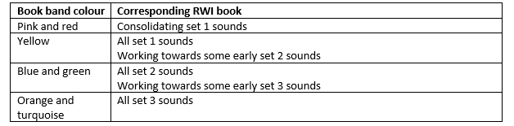

We will be attaching some resources that you might find useful over the next few weeks. You should have received a green home learning book for your child at the beginning of the school year for your child to use for their learning. If this runs out any lined paper will be sufficient. Please try to complete work using a pencil where possible. Please keep any work you do with your child in one place.

Reading wise, we will keep bug club updated. We understand that you will be doing everything you can to support your child’s learning at home, while trying to balance your own work as well, and it may feel that you have a lot of resources and information coming from us in the next few weeks. Our message to you is that if you are finding it hard to fit things in please prioritise reading with your child as often as possible. Everything else you can do is a bonus.

Thank you again for all of your support. We understand that this is a very difficult situation for all our families but we ask you to be patient with us as we attempt to work together to navigate through these uncertain times.

Yours sincerely

The Year 1 team

