Pingle Road
Sheffield, S7 2LN
Tel: 0114 2368099

School email: enquiries
@dobcroft-inf.sheffield.sch.uk

Website: www.dobcroft-inf.sheffield.sch.uk
Twitter: @DobcroftInf

Head teacher: Mrs Cathy Rowland,
headteacher@dobcroft-inf.sheffield.sch.uk

Deputy Head teacher: Mrs Vicky Harrison,
deputy@dobcroft-inf.sheffield.sch.uk

Chair of Governors: Andy Gates,
chair@dobcroft-inf.sheffield.sch.uk



Infant School

Dear Reception Families

We are writing to you to keep you updated on our plans for remote learning in the coming few weeks. As you can imagine, we are having to adapt rapidly to a changing situation. We will try to keep you as updated as we can throughout. Thank you in advance for all of your support.

Regarding home learning, each Friday we will upload the following weeks remote home learning to the gallery page on the website. We will also upload a suggested weekly timetable, which will mirror the learning taking place in school, so if your child has any days in school you will know which lessons they have done. This may include:
- A daily maths focus (including number formation practise)
- A daily writing focus (including handwriting some weeks)
- Daily reading
- Topic, for example a weekly activity covering the following foundation stage areas; Understanding the World (history, geography,) R.E. Expressive art(art, design technology, music) P.E, and PSHE.
We will include videos of us talking through some of the lessons for your child, and there may be some videoes of key learning activities such as maths methods or story maps. Some lessons may also be learning from Oak Academy or BBC bitesize. Please feel free to explore these resources if you wish to use this for your learning.

For RWI phonics, Ruth Miskin (creator of the RWI phonics scheme) will be uploading daily videos to YouTube, you can find by following this link. She is uploading a set 1, set 2 and set 3 video every day. There is a schedule which we will attach with this letter. This table shows which sets you should use for you child.

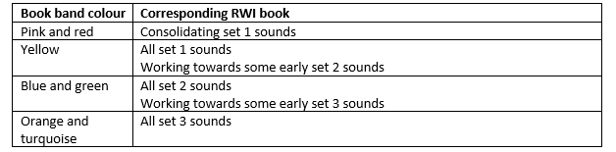

Reading wise, we will keep bug club updated. We understand that you will be doing everything you can to support your child’s learning at home, while trying to balance your own work as well, and it may feel that you have a lot of resources and information coming from us in the next few weeks. Our message to you is that if you are finding it hard to fit things in please prioritise reading with your child as often as possible. Everything else you can do is a bonus, and if you don’t do it all, don’t worry! Remember baking, folding washing, pairing socks, gardening are all valuable learning opportunities and the most important thing is to keep talking.

Thank you again for all of your support. We understand that this is a very difficult situation for all our families but we ask you to be patient with us as we attempt to work together to navigate through these uncertain times.

Yours sincerely

The Reception team

