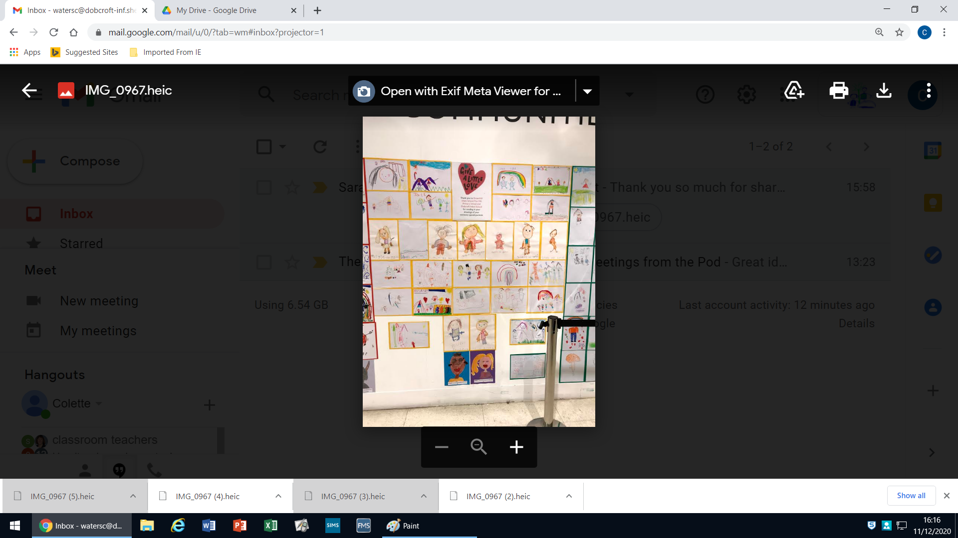

**Our lovely artwork being displayed in John Lewis**