Squirrels Christmas Poem

The squirrels will be performing this poem as part of our ‘new normal’ Christmas celebrations this year. If you are able, please spend some time practising it at home with your child.

Thank you

Mrs Holmes and Mrs Waters

Santa’s Workshop
In Santa’s Workshop elves are seen,
Running to and fro.
Making lots of toys and games,
For Santa Claus, you know.

Painting trucks and dressing dolls,
For all the children’s fun.
Lacing skates and printing books,
The elves are never done.

Till it is time to pack the sleigh,
With all the elf-made toys.
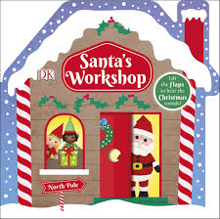
So Santa can deliver them,
To all good girls and boys!

