WC 16.11.20
WALT Write about what makes me happy.
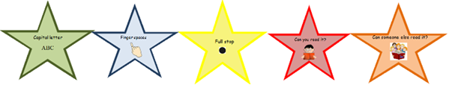
I can hear and represent the sounds in words I want to write.
I can use finger spaces
I can use a full stop

