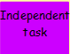
Write these numbers into your book and partition them into 100s, 10s and 1.
Example:
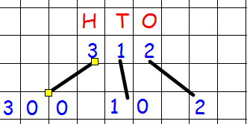
251
675
122
213
546
103
295

