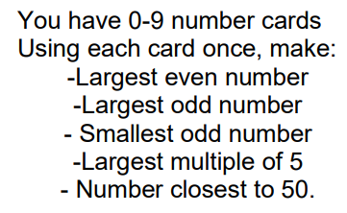
Answer it:

Largest even number
Largest odd number
Smallest odd number
largest multiple of 5
Number closest to 50

Compare these numbers using = < or > :

4 tens and 17 ones 6 tens

8 tens and 11 ones 7 tens and 7 ones

3 tens 2 tens and 10 ones

Answer it:

Largest even number
Largest odd number
Smallest odd number
largest multiple of 5
Number closest to 50

Compare these numbers using = < or > :

4 tens and 17 ones 6 tens

8 tens and 11 ones 7 tens and 7 ones

3 tens 2 tens and 10 ones

