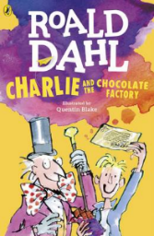
Charlie and the Chocolate Factory
Read Chapter 13 and 14 of the book or listen to it using this link https://www.youtube.com/watch?v=qCuNSZjCKg8

1) Listen to the story.
2) Discuss key questions.
3) Use the text to find evidence and answer the questions.

- Match the description for each of the five winners to their name:
(pages 66-68)

The little girl in the silver mink coat Charlie Bucket
Skinny little shrimp Violet Beauregarde
Still chewing that dreadful old piece of gum Mike Teavee
The television fiend Veruca Salt
The big, fat boy Augustus Gloop

- Why does Willy Wonka have to keep it warm inside the factory? (page 73)

- What is the first room the group come to called? (page 76)

