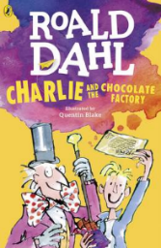
Charlie and the Chocolate Factory
Read Chapter 12 of the book or listen to it using this link https://www.youtube.com/watch?v=qCuNSZjCKg8

1) Listen to the story.
2) Discuss key questions.
3) Use the text to find evidence and answer the questions.

- “Rushing in on them like a hurricane.” (page 57)
This means Charlie was..

Walking slowly Running

Striding Tip-toeing

- Why was it surprising that Grandpa Joe jumped onto the floor and started doing a dance of victory? (page 58)

- What date and time does Charlie need to be at the Wonka factory gates? (page 61)

