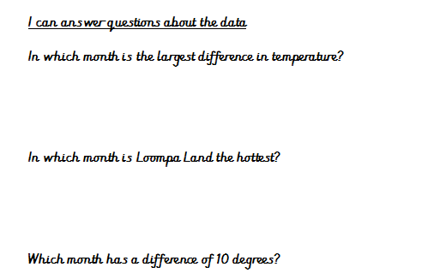

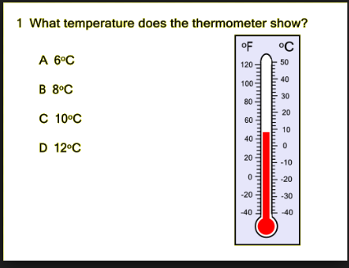

If it was 10 ˚c warmer, how hot would it be?

On Thursday it was 5˚c colder. What was the temperature on Thursday?

