Average maximum temperature in Loompa Land
Month | Jan | Feb | Mar | Apr | May | June | July | Aug | Sept | Oct | Nov | Dec
Temp  ($℃$) | 31 | 31 | 31 | 30 | 29 | 28 | 28 | 28 | 28 | 29 | 30 | 30

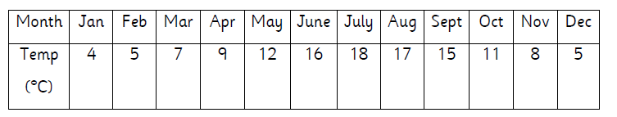
Average maximum temperature in Sheffield, England

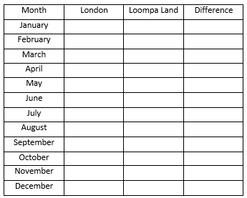
Loompa Land
Sheffield

