**Key Learning:** to measure and read temperature and find the difference using subtraction 7.7.20

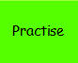**Task1**

Write the correct temperature underneath each thermometer.

Check what each thermometer’s scale is going up in (2, 5 or 10).

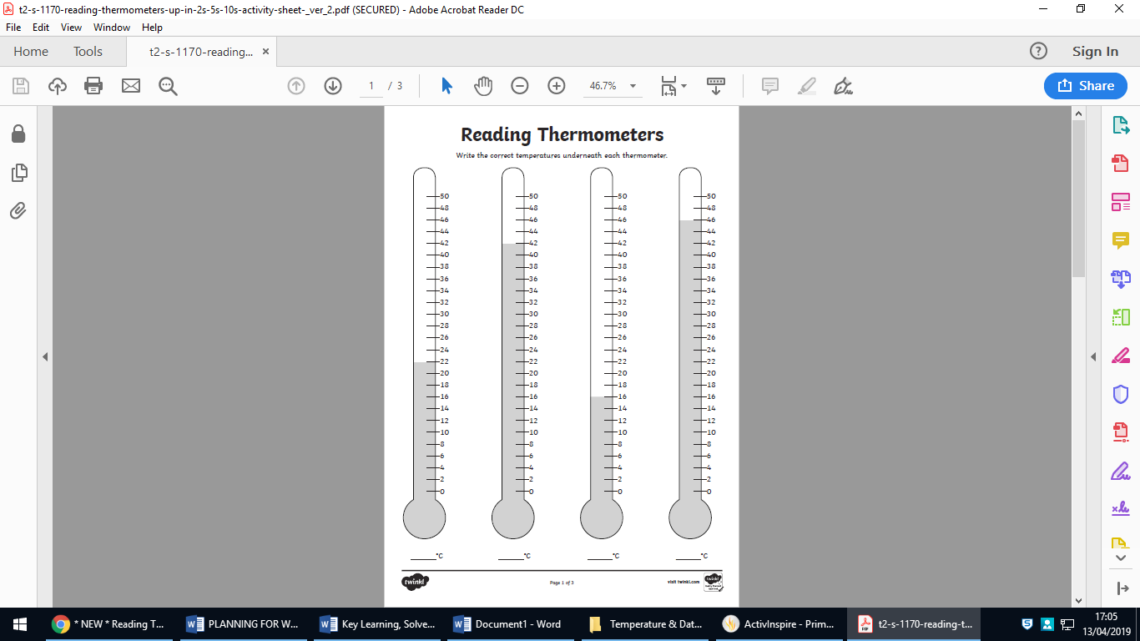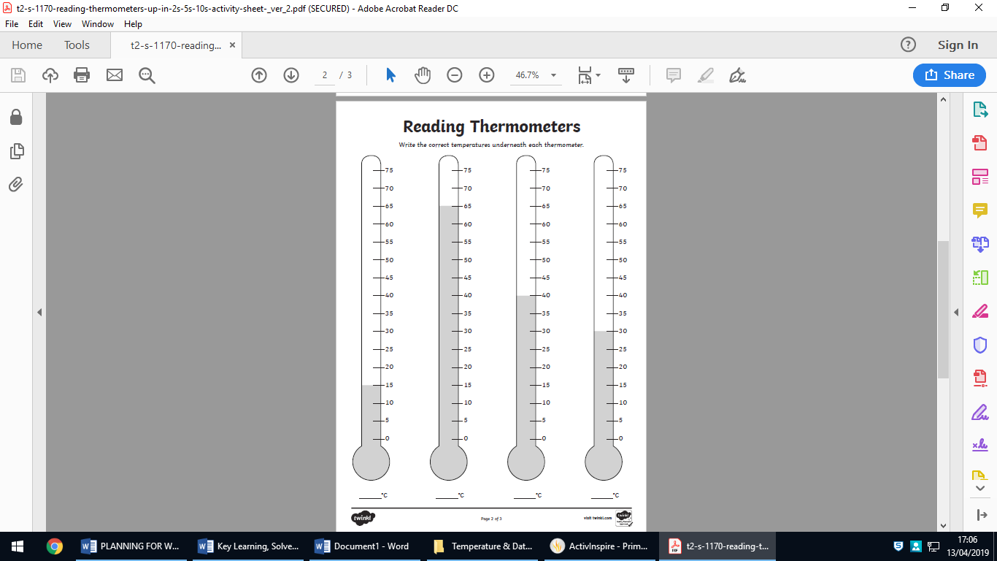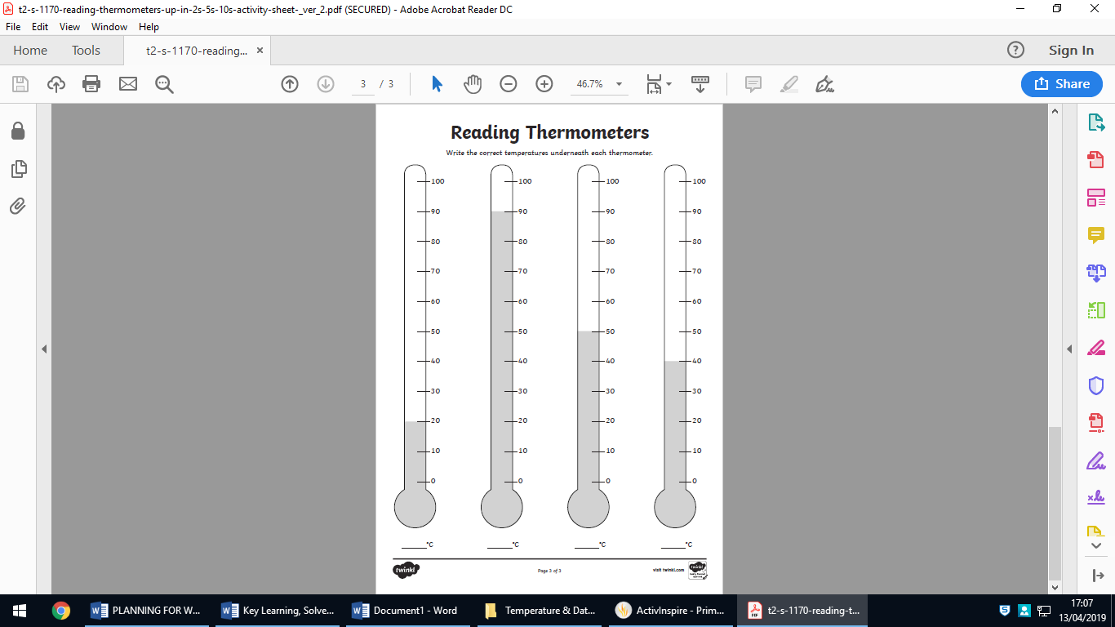

**Task2**

Shade the thermometer in pencil to show the correct temperature written underneath each thermometer.

