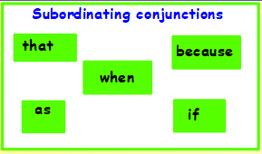
WALT identify sentence types
Remember to:
1. Know the definitions
2. Underline the co-ordinating conjunctions
3. Underline the subordinating conjunctions
4. Use the independent clauses to write compound and complex sentences
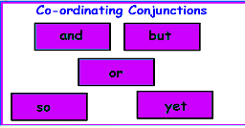
5. Write a paragraph containing compound and complex sentences

Task 1 – Practise & Consider
Underline your coordinating conjunctions in purple and subordinating conjunctions in green.
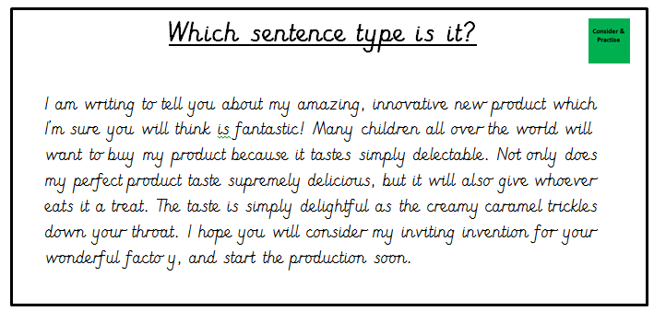
Then label each sentence as either compound or complex.

Task 2 – Independent
Write your own paragraph about your product using compound and complex sentences. Use your product plan to help you.

Review & Improve
Which one is the odd one out? Why? Explain your answer.

I swallowed the glorious jumping jellybeans.

The gigantic gobstopper changed flavour ever 5 seconds, and the different tastes made your taste buds melt.

The Oompa Loompa's helped Willy Wonka create his new products, but often made silly mistakes that would make him mad.

