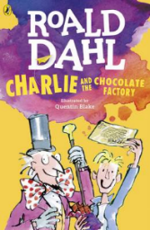
Charlie and the Chocolate Factory
Read Chapter 9 and 10 of the book or listen to it using this link https://www.youtube.com/watch?v=qCuNSZjCKg8

1) Listen to the story.
2) Discuss key questions.
3) Use the text to find evidence and answer the questions.

1. What Wonka bar did Charlie buy with Grandpa Joe’s money? (page 43)

What 3 expanded noun phrases could you use to describe what you think the bar would look or taste like?

2. Draw and label a picture of which food you would crave if you had no food to eat.

3. What two changes did Charlie make to save his strength? (page 49)

