Summer Term 2: Week 2
History
Significant people in History

Over the last few weeks we have learnt about 2 significant women in British history.
Who are they? Why are they significant?

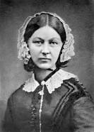
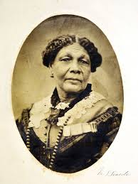

This week we would like you choose your own significant historical figure. They could be anyone from history that has:
- Been a king or queen – such as Boudicca, Henry VIII, Elizabeth I, Charles I
- Made an important discovery – such as Thomas Edison, Tim Berners-Lee, Ada Lovelace
- Changed the society they live in – Nelson Mandela, Rosa Parks, Emmeline Pankhurst
- Explored new worlds – Neil Armstrong, Helen Sharma, Tim Peake
- Created art or wrote stories – Anne Frank, William Shakespeare, Vincent Van Gogh
Or pick someone you would like to find out about!
You could
- Make a fact file
- Create a power point presentation about them
- Write a diary entry as them
- Write a story about their life
- Create a big poster with lots of information about it on them
- Or think of your own ideas!
As usual your teacher would love to see what you have created.
The BBC bitesize website has lots of short videos about some significant historical figures
https://www.bbc.co.uk/bitesize/topics/zf49q6f Have fun!

