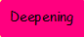
3D shapes: Can you describe the faces, vertices and edges?

Shape | Name of shape | Describe the shape (faces, edges, vertices)

