Key Learning: to solve addition and subtraction missing box equations 23.6.20
Success criteria:
- I know if it is the part or whole missing
- I know how to find the missing part or whole
- I can solve addition and subtraction missing box equations (crossing tens)

Put the parts and whole into the bar model.
Engage

25 – 16 = 9
19 + 11 = 30
12 + 4 = 16

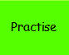
Write an equation to find the number that is missing from the bar model.
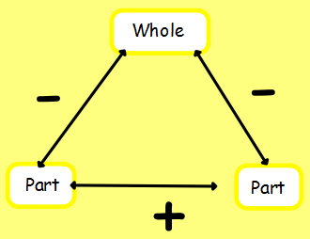
Label the bar model with W and P and P to help you!
