5 + ____ = 15

____ + 6 = 18

19 - ___ = 11

____ + 5 = 16

35 - ___ = 31

____ - 7 = 23

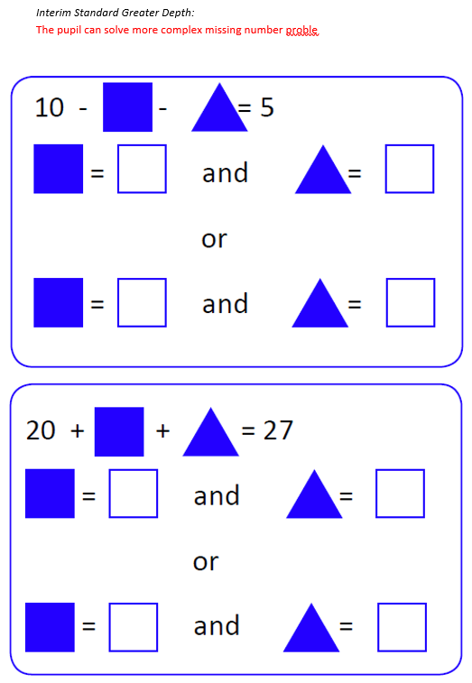
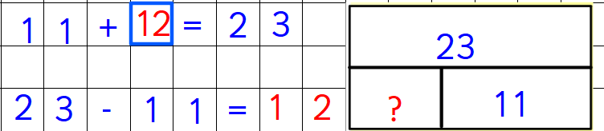
WAGOLL:

