Key learning: to solve addition and subtraction missing box problems. 22.6.20
Success criteria:
- I can label the parts and the whole
- I know how to find the missing part or whole
- I can complete missing box equations (addition and subtraction)

26+13 | 43-31= | 6x5= | 25÷5= | ½ of 14=
31+17 = | 55-32 = | 4 x 10 = | 20 ÷ 2 = | ¼ of 24 =

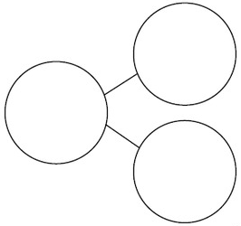
Label the equation with the parts and whole, then fill in the part-part-whole and the bar model:

7 + 9 = 16

34 - 23 = 11

8 + 12 = 20

