WALT use a variety of SPaG features
1. Correct the punctuation errors in the text
2. Find examples of SPaG features
3. Fill in the example of each from the text
4. Change the SPaG mistakes in the given text
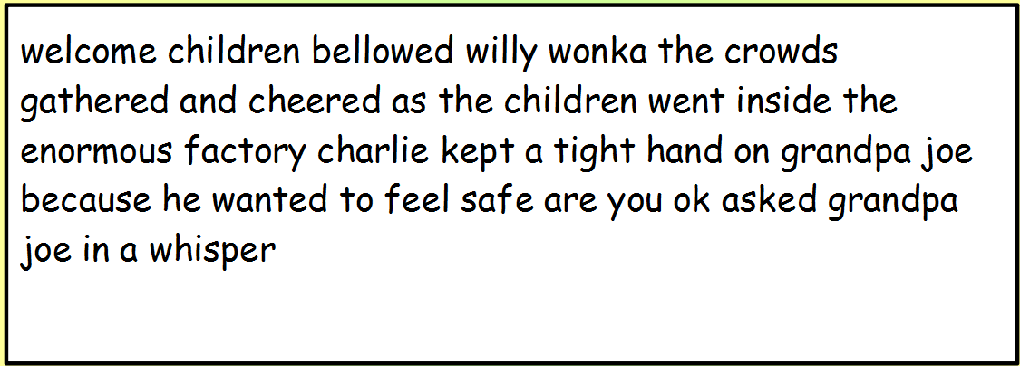
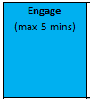

My eyes gazed in wonder at the marvellous sight. I wanted to soak up all the atmosphere, but I couldn’t believe what I was seeing. The magical, glistening sweets hung from the candy trees. Every time I took a step past them they swayed in the breeze, and the glorious scent of them wafted through the air. Excitement was traveling through the room as we galloped over the crunchy grass. “Can we try the sweets?” a voice asked from a far.
“Don’t eat too many.” Was the reply from Willy Wonka, “I won’t be cleaning up your mess!”
How wonderful the treats tasted! We ran from place to place in the room because there was so much to see and try. Suddenly there was a shriek from the impressive chocolate river. Augustus Gloop’s hand was now the only visible part of him waving from the brown water.

SPaG Detective:
Circle an example of capital letters and full stops

Expanded noun phrase:
Compound sentence (co-ordinating conjunction):
Complex sentence (subordinating conjunction):
Question sentence:
Exclamation sentence:
Command sentence:
Suffixes:
Apostrophe for omission:
Apostrophe for possession:
Commas in a list:
Deepening Task
All of the childrens mouths began watering as they stared at the wundful delicious sweets in front of them. What an exiting day this wos. Charlie dasht quikly over to the sticky lollipops and happyly jumpt over sum gum drops that hade fallen. He lookt carfuly at all the tasty treets as he didnt no wat to hav. How culd he evr decide. He walked past the mint sugar grass chewy gummy bears and candy berryes. Finly, he stopt at the delectable candy cane trees and puled one from the tallist tree.

