Week beginning 15.06.2020 Incy Wincy Spider

|  |  |  |  |  |  |
| --- | --- | --- | --- | --- | --- |
|  | Monday | Tuesday | Wednesday | Thursday | Friday |
| Literacy | Follow usual daily routines and timetable. Spend time talking, getting used to new routines, taking turns to speak, etc.  Play some games like musical statues or musical bumps to get used to listening again.  Show the children their books and look through them together in small groups or individually.  What do they remember? What did they like about the Ladybirds? What can they do now that they couldn’t then? Can they talk about themselves and their experiences? | Read the incy wincy spider book  Talk about the rhyming words in the book.  Who likes spiders? What do you know about them? | Sing the incy wincy spider song. Miss out some words. Can they fill the gaps? | Using one of the puppets, play Simon the Spider says. See if any confident ladybirds want to be Simon. | Learn about spiders. Go to the library and find books on spiders. Google ‘Come outside spiders’ and watch the episode. Talk about what happens and what you find out. |
| Maths | Make the black circles with numbers to 10 on like the image below. Can the children see any numbers they know? Can they order them? Can they put the right number of pegs on? | Repeat yesterday’s game as a group.  Once you have the number line made, children shut their eyes. Take a spider away. Which one is missing?  Repeat  Ask a child to take one while everyone hides their eyes | Have two sets of number cards to 10. Shuffle the cards. Lay them out face down and teach the children to play ‘pairs’. If they turn over two numbers the same, they keep the pair. If not, they turn them back over. This is good for turn taking and language over more or less. | Play either pairs again, or teach the children a simple game of play your cards right. Take turns to say if the next card will be a bigger or smaller number. Talk about what card you turn over. This game leads to good conversations about higher and lower, greater and smaller, more, or less and can lead on to ordering as an extension |
| PSED  UTW | Look at books again if they want to. Can they show a friend? | Make a friend web:  Sit children in a circle. Roll a ball of string to one and say their name. they roll to a friend and say their name and so on until the string has made a web. Look at how you are all joined together by your friendship like a little family! | Go on a spider hunt outside. Can you find a w-e-b? Take a spray bottle with water in. when you find a web, mist it gently with water. Can you see the web? | See if they can find any minibeasts outside. Support them by scaffolding their thinking ‘I winder where might be a good place to look…’ etc |
| Creative | Make a spider puppet with black handprints  Use the puppets to say the rhyme. | Finger print spiders (see picture below) | Drizzle glue onto a square of black paper to make a web. Cover with silver glitter and shake off. Use your hand print spiders to decorate your web | Make a web inside using wool or, can you make a spider cave using the outdoor loose parts? |
|  | 8+ Simple Incy Wincy Spider Activities - Learning Puddles | https://theimaginationtree.com/wp-content/uploads/2013/01/spider+puppets.jpg |  |  | The Very Busy Spider by Eric Carle |

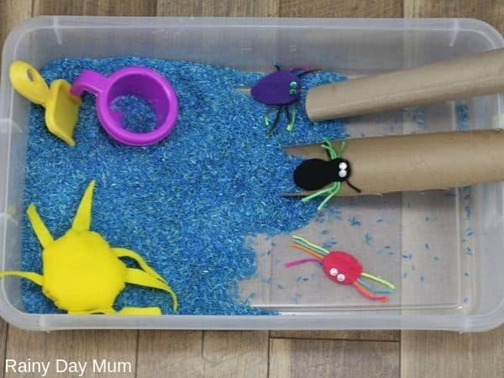 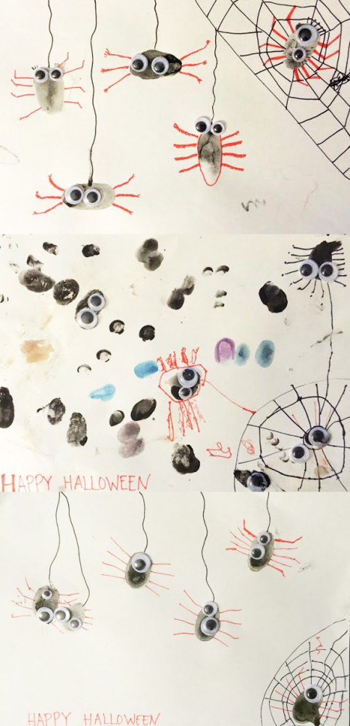

Other ideas:

Leave the spider puppets out with a pipe and a watering can and see if the children independently retell the story or say the rhyme.

Leave the puppet making or fingerprint equipment in the provision to see if children repeat the activity on their own.

Encourage more able children to make a little zig zag book of the incy wincy rhyme, or draw a simple story map.