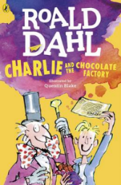
Charlie and the Chocolate Factory
Read Chapter 5 of the book or listen to it using this link https://www.youtube.com/watch?v=qCuNSZjCKg8

1) Listen to the story.
2) Discuss key questions.
3) Use the text to find evidence and answer the questions.

- Who has the newspaper article been written by?

- How does the newspaper describe Willy Wonka in the introduction?

- Does Charlie think he has a chance of winning a golden ticket?
Yes No

Why does he feel this way?

- Which family member thinks that Charlies does have a hope of winning a golden ticket?

Mr Bucket Grandpa George Grandma Josephine

Mrs Bucket Grandma Georgina Grandpa Joe

- Who does Grandpa George think are going to be the kids that will find the Golden Tickets?

