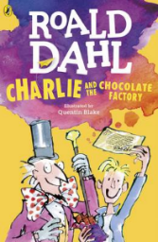
Charlie and the Chocolate Factory
Read Chapter 4 of the book or listen to it using this link https://www.youtube.com/watch?v=qCuNSZjCKg8

1) Listen to the story.
2) Discuss key questions.
3) Use the text to find evidence and answer the questions.

- Match the invention to the factory:
Never melting ice-cream Mr Slugworth’s Factory
Chewing-gum which never Mr Prodnose’s Factory
loses its flavor

Sugar balloons Fickelgruber’s Factory

- ‘Then something astonishing happened’
What does the word ‘astonishing’ mean?
_________________________________________________________________

- How did people know the factory was working again?
Tick 3

Heard the machines Smell the chocolate Gates were open

Visitors were allowed in Saw the shadows of workers It was announced

Explain your choices:
__________________________________________________________________________________________________________________________________
_________________________________________________________________________________

