1. Write out the calculation
2. Look at the symbol to identify if you are dividing (÷) or multiplying (X)
3. Show your working out
4. Find the answer - check using your number facts
(e.g - multiples of 5 end in 0 or 5)
You get 6 chocolate bars in a packet and Charlie buys 6 packets. He then shares half of them with Grandpa Joe. How many chocolate bars do they get each?

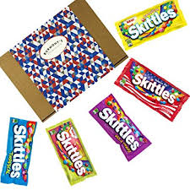
The Oompa Loompas works in Willy Wonka’s factory. They have to box up sweets into boxes of 5. If they have 45 sweets, how many boxes will they need?

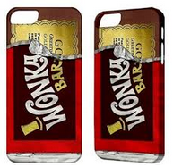
Willy Wonka phones 3 of his Oompa Loompas. He is on the phone for 10 minutes to each one. How long is he on the phone for altogether?

Veruca’s dad and his 4 factory workers opened up 50 bars of chocolate altogether.
How many did they open each?

Charlie buys 3 sweets for 5 of his friends. He then buys 9 lollies for his 2 parents. How many items did he buy altogether?

