Lesson 3 17.06.20
Key Learning: to solve multiplication and division word problems
Success criteria:
- I can match an array to the equation
- I can write the equation for and solve word problems
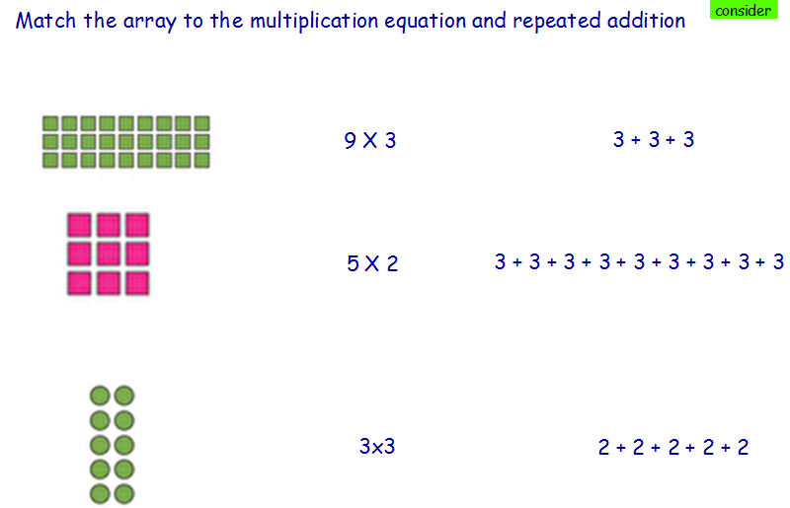

Write the equation on the line below.
Consider and Practise

Willy Wonka shares 30 everlasting gobstoppers equally between the 5 children. How many does each child have?

Charlie finds 4 chocolates in 5 different rooms of the chocolate factory. How many chocolates does he find altogether?

Grandpa Joe finds 18 bubblegum sweets, and he gives half to them to Charlie. How bubblegum sweets does Charlie have?

Verruca has 7 candy apples. Violet has double this. How many candy apples does Violet have?

_____________________________________________________________________

