

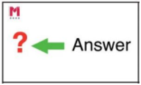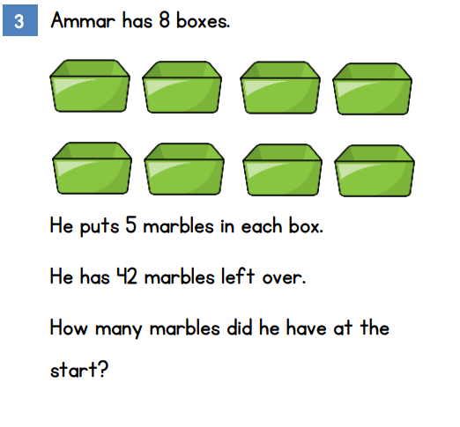

Use the signs (< > or =) to solve these calculations.

2 X 10 5 X 4

60 ÷ 10 6 X 10

11 X 2 25 ÷ 5



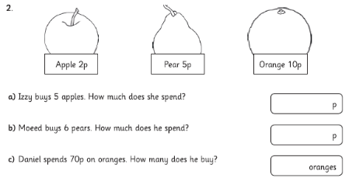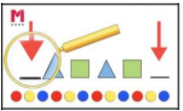

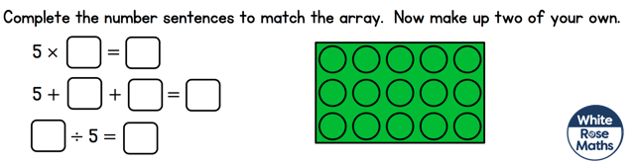

Complete the equations to match the array.