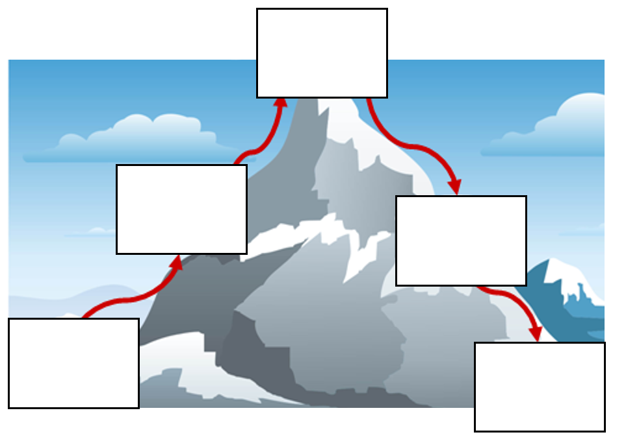.

Resolution

Problem

Build up

Ending

Introduction