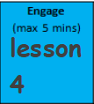
Key Learning: Solve a word problem using addition
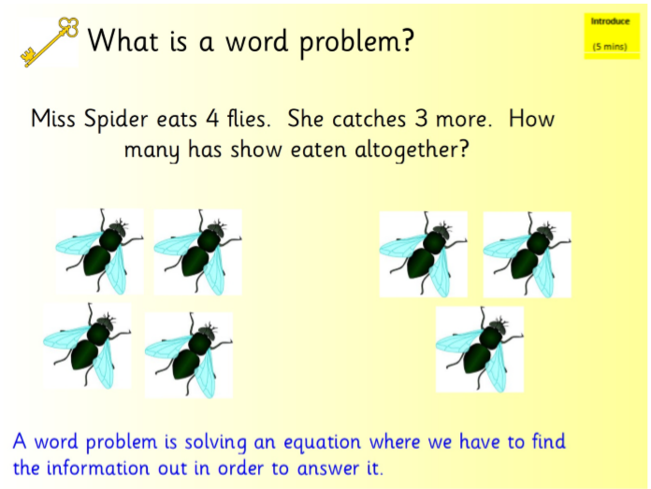
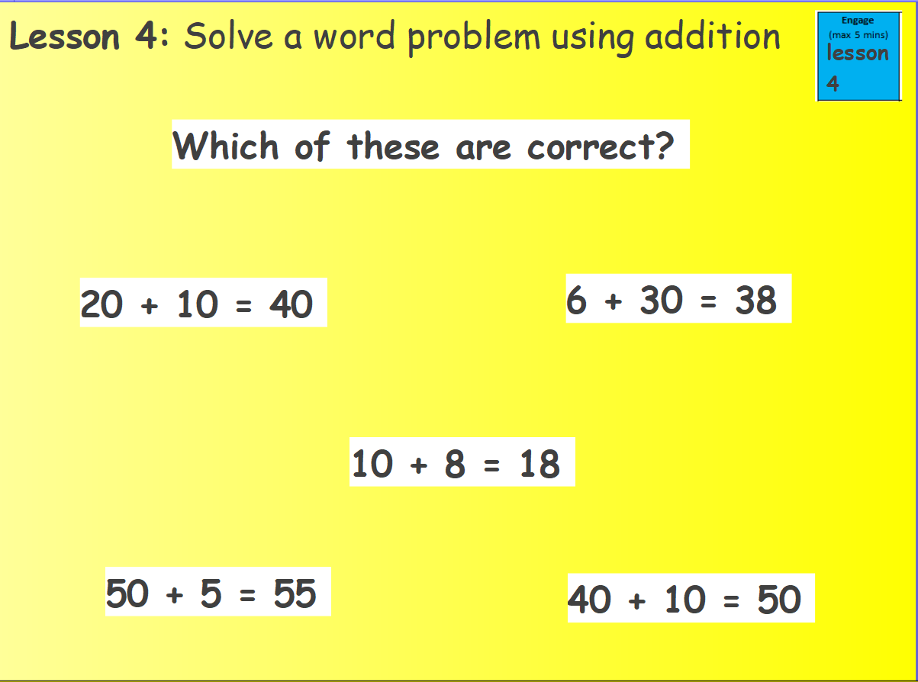

Independent Task
Read the questions and find the key information (the numbers and your clue that it is adding).
Write the equation for the word problem and then use a method of your choice to solve the problem. Remember that you can draw the tens and ones to help you.

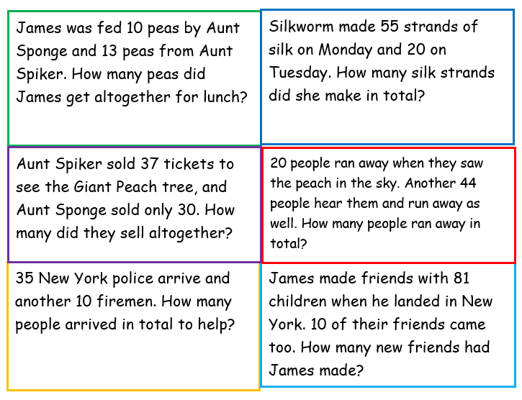
It might be helpful to cut up the word problems to solve one at a time and write the equation to the side.

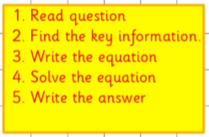
Remember:

Can you create your own word equation with an addition of a 10s number?

