18 | 44 | 29
Key Learning: Add 10s to a number within 100
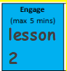
Can you draw the tens and ones for these numbers? Remember we draw lines for tens and dots for ones.

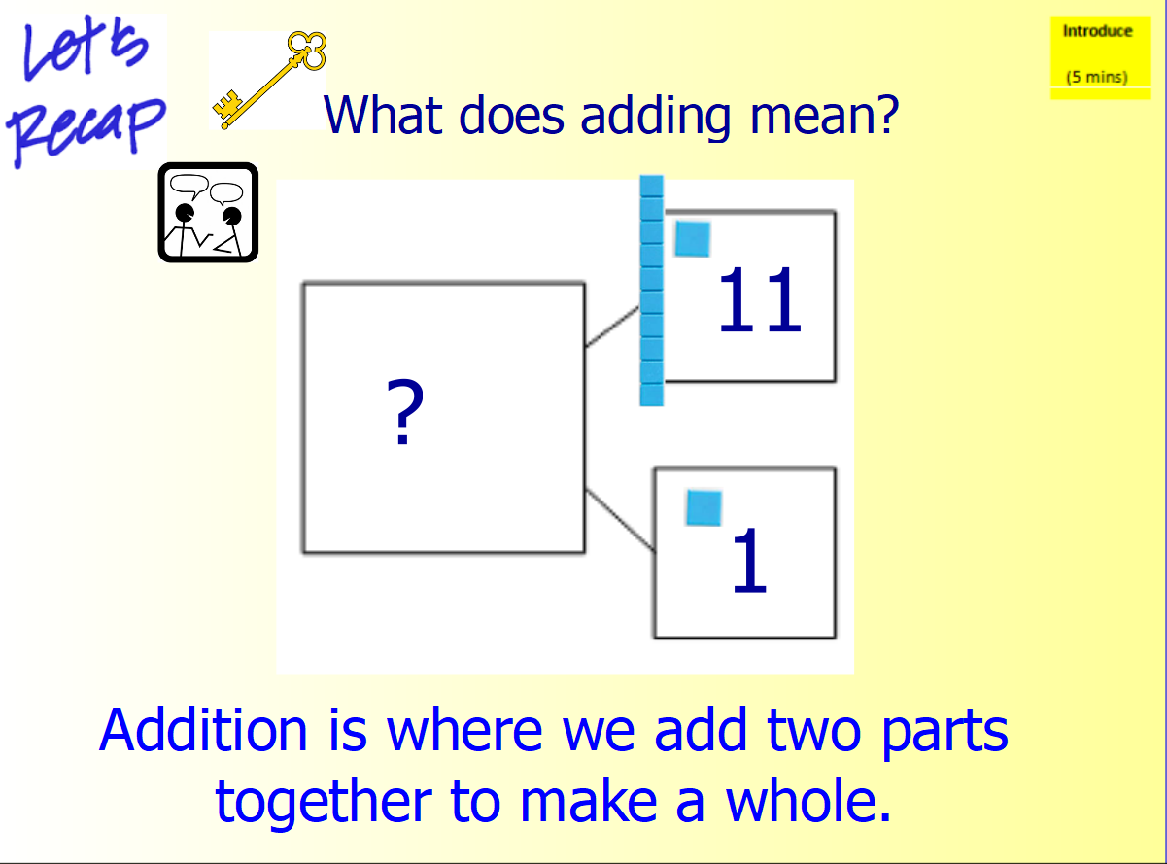

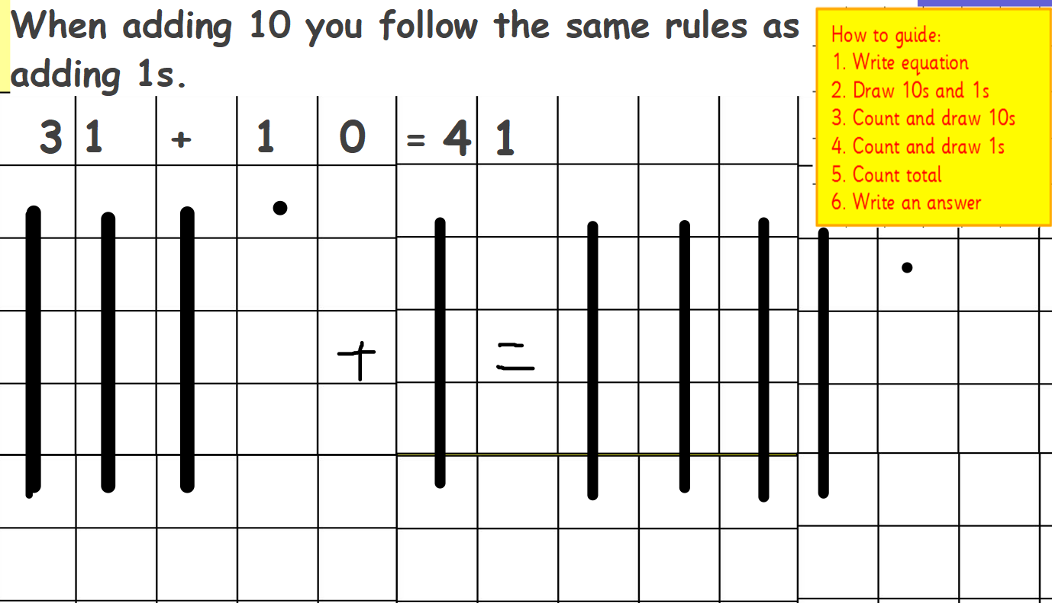
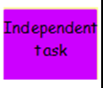

Can you draw the tens and ones for these equations to help you work out the answers?
Spicy
- 55 + 20 =

- 41 + 30=

- 73 + 20=

- 29 + 30=

- 37 + 30=
Hot
- 21 + 40=

- 51 + 40=

- ? = 47 + 20

- ? = 18 + 30

Mild
- 22 + 10=

- 31 + 10 =

- 18 + 10 =

- 72 + 10 =

