Key Learning: Represent numbers within 100
Watch this video of 100 days of cool. Can you spot all 100 numbers?
https://www.youtube.com/watch?v=viLbb15_cts
Search for 100 days of cool in youtube if you cannot follow the link.
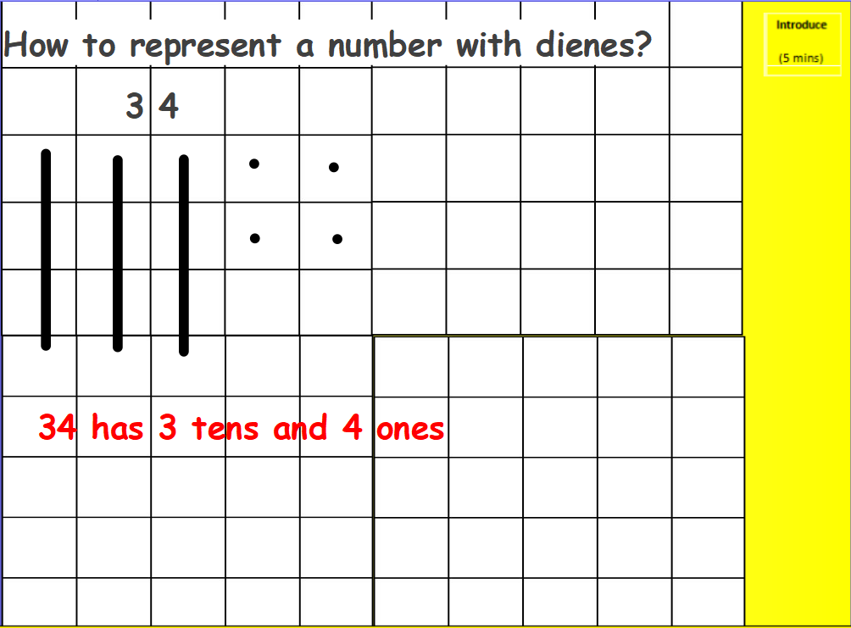

To represent numbers with dienes by drawing we draw lines for the tens and dots for the ones.
Independent task: Draw the tens and ones for these numbers.

