Key Learning: to complete addition and subtraction investigations 12.6.20
Success criteria:
- I can use my addition and subtraction skills to complete investigations
Deepening - I can complete further investigations
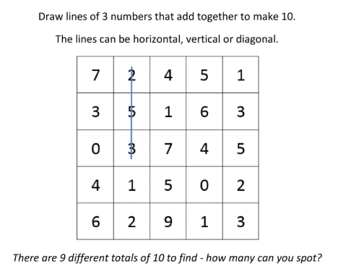
Engage

