Independent

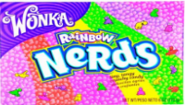
- There are 50 Nerds in a box. There are:
- 10 green
- 5 red
- 5 pink
- 10 purple
All the rest are blue. How many blue ones are there?

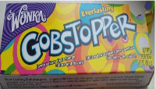
- Willy Wonka has 13 everlasting gobstoppers. He gives 7 to Charlie, 3 to Grandpa Joe and the rest to Mike. How many does he give to Mike?

- a) If there are 5 children, 5 adults, Willy Wonka and 12 Oompa-Loompas on the boat going down the chocolate river, how many are on the boat?

b) 6 Oompa Loompas get off the boat and go into the Fudge room. How many are on the boat now?
