Lesson 4 – WALT use co-ordinating and subordinating conjunctions to write compound and complex sentences
Task 1 (Engage) – Conjunctions card hunt around your house! (See separate sheet)

Task 2 (Practise & Consider)
Highlight the conjunction in each of the sentences. Then identify what type of conjunction has been used, and what type of sentence it is.

- I felt my jaw drop in amazement as the large metal door slowly swung open. co-ordinating / subordinating compound / complex

- The bejewelled blades of mint grass looked perfect and untouched, so I carefully tiptoed across them. co-ordinating / subordinating compound / complex

- I was eager to explore the vast chocolate room, but I didn’t want to anger the eccentric Mr Wonka. co-ordinating / subordinating compound / complex

- Hanging from the sugar coated branches were crystallised leaves which glistened in the sunlight. co-ordinating / subordinating compound / complex

Task 3 (Independent)
Write a compound sentence using a co-ordinating conjunction.

Write a complex sentence using a subordinating conjunction.

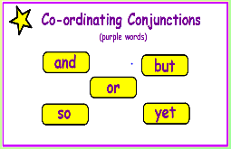
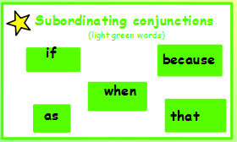

REVIEW AND IMPROVE – Can you spot the odd one out? Give a reason why.
(HINT: there may be more than one answer!)

- There were bright green meadows on either side, and a winding, chocolate river along the bottom.

- I quickly dashed around the maze of tasty treats because I wanted to try everything in sight.

- When I tasted the flower’s petals, an explosion of sweet and sour sherbet danced upon my tongue.

“I think... because...”

