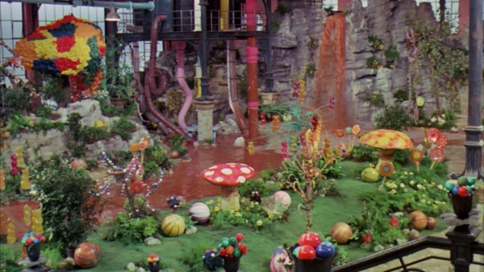

**The Chocolate Room**

**WALT: generate interesting vocabulary**

Context: The Chocolate Room

Remember to:

1. Imagine what you would see, hear, smell, feel or touch in the chocolate room. Write these in the noun box.

2. Write adjectives that describe the nouns into the adjective box.

3. Write verbs that explain what the nouns are doing.

4. Write adverbs to explain **how** the verbs are being done.

**nouns**

**adverbs**

**adjectives**

**verbs**