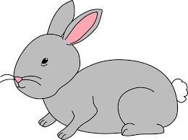
Home Learning Challenge 9/6/20
Challenge 1 – Word Problems!
Choose a selection of toys. Make a series of addition and subtraction word problems for your child involving these toys using numbers 1 - 20?
For example There were 11 horses in a field and 6 jumped over the fence. How many were left in the field?
I had 6 apples in my basket and picked 8 more from the tree. How many do I have in total?
Can the children identify if this is an addition or subtraction problem.
Encourage your child to use concrete resources to solve these problems.
Check on a number line, do you get the same answer?
We have attached some word problem cards for you to have ago at.
Extension
Can you record the addition or subtraction number sentence that you have solved?
Can you solve a twostep problem
E.g. My cat has three Kittens and two went to live in a new home. How many cats were left in my house?
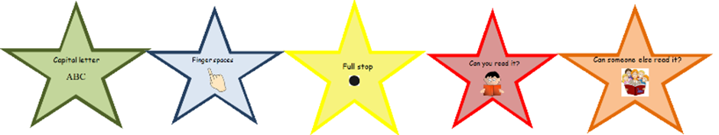
Challenge 2 – Can you write a question?
Choose somebody to write to that you haven’t seen for a little while. Can you think of three questions to ask them?
“What, Where, When, How, Why” are all good questioning words.
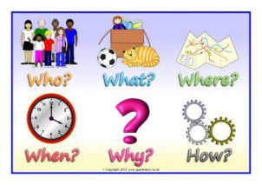
What needs to come at the end of a question?
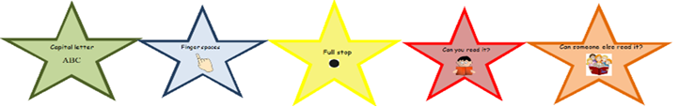
Purple Mash
In school the children have been learning about England, Wales, Scotland and Northern Island. Have a look at these flags. Can you design a flag of your own?

