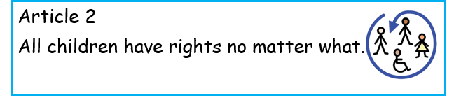

https://www.bbc.co.uk/programmes/articles/7xvLw6Q4qbJBnkzkj6xm9Z/how-to-talk-to-your-children-about-race-and-racism - tips on how to talk to children about race from Radio 4’s Woman’s Hour
https://equaliteach.co.uk/how-to-talk-with-children-and-young-people-about-race-and-racism/
some ideas of how to talk to children about race and more recommended reading
https://biglifejournal-uk.co.uk/blogs/blog/raising-inclusive-kids?_pos=1&_sid=c004c6fe4&_ss=r&utm_campaign=Inclusion%20Newsletter%20%28RA5DpT%29&utm_medium=email&utm_source=Big%20Life%20Journal%20Printables%20UK&_ke=eyJrbF9lbWFpbCI6ICJoZWFkdGVhY2hlckBkb2Jjcm9mdC1pbmYuc2hlZmZpZWxkLnNjaC51ayIsICJrbF9jb21wYW55X2lkIjogIk5iUU1RNCJ9
Ideas and tips:
- Buy some skin tone colouring pencils and have them out for your child to use in their drawing
- Buy toys and figures that reflect different races and cultures
- Make posters or draw pictures about article 2 – All children have rights no matter what
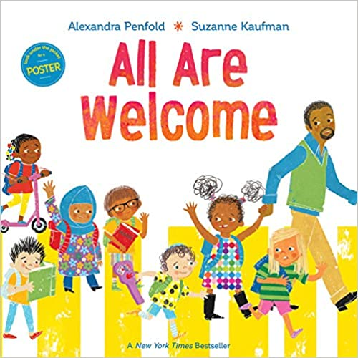
- Read books about children from different cultures and races. Some examples are included in the attached power point and here are some more examples:
