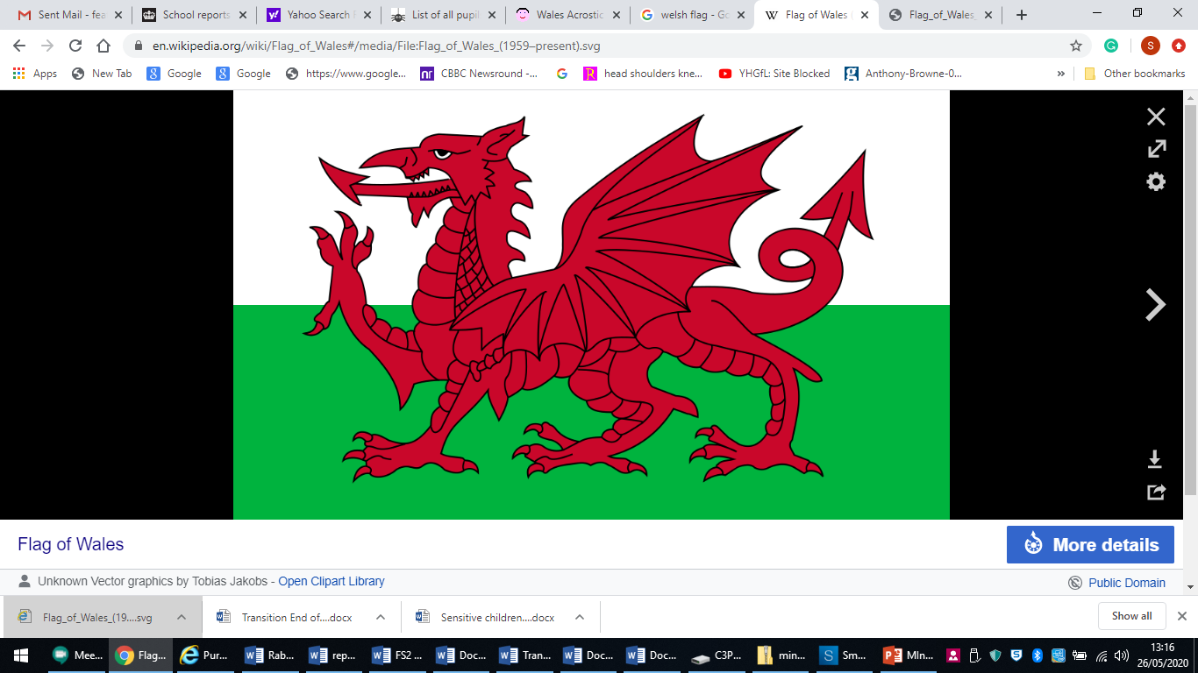

|  |
| --- |
| **W** |
| **A** |
| **L** |
| **E** |
| **S** |