Summer Term 1: Week 6
Music task: composing your own music for a picture or film clip

Miss Hughes was watching a film over the weekend and realised how the music had a huge effect on how she felt. The music built up tension in scary parts and made her feel calm in peaceful parts – and sometimes having no sound at all added to the tension and then a sudden loud bang would make her jump! Some films use uplifting, joyful music to tell us we are supposed to like certain characters, or to show a happy ending.

Your challenge this week is to compose some music to go with one of the pictures below.
Use household objects to be as creative as you can to achieve the sounds you want. A cheese grater with a wooden spoon can be transformed into an instrument, and you can use your own body percussion such as rubbing hands together, clapping, tapping on a surface or clicking your fingers!

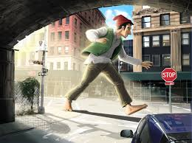
A giant walking through a town
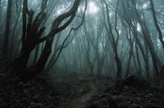
A spooky, misty forest at night
A bright, busy funfair

Think about what you can see and how that might sound.

An animal walking through a forest might make tapping noises as it walks, the trees might whoosh in the wind, and there might be dripping of water from a nearby river. If it’s daytime you might hear other animals, if it’s night time it might be quieter.

You can record your sound story and email it to your teacher
(hughesc@dobcroft-inf.sheffield.sch.uk
homesk@dobcroft-inf.sheffield.sch.uk
shawg@dobcroft-inf.sheffield.sch.uk
machina@dobcroft-inf.sheffield.sch.uk)

I’ll ask Mrs Harrison if we can post a few to Twitter for everyone to enjoy!
Miss Hughes

