Summer Term 1: Week 6
Maths – Activity 3
Hi everyone!
So today we are going to be thinking about reading scales. Let’s start by looking around your house and finding items that have a scale on it. How many can you find?
Have a look at the scales that you have found. What is the same? What is different?
You may have noticed that all the scales go up in even steps (2s, 5s, 10s, 100s etc).
Task 1
Each scale will have a different unit of measure depending on what it is measuring.
Match the unit below to the picture of the correct scale.
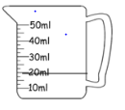
centimetres (cm)
grams (g)
millilitres / litres (ml / l)
degrees Celsius

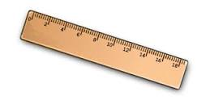
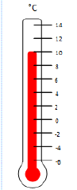

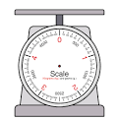

What type of things would we measure with each of these scales? Write your ideas below.
Measuring jug –

Ruler –

Weighing scale –

Thermometer –

Task 2
Look at the different scales below. Write in the box the amount that it is showing (don’t forget your unit of measure). Then add a greater than (>) or less than (<) symbol to show which scale shows the largest amount. (Extra Challenge – can you work out the difference between each of the amounts?)
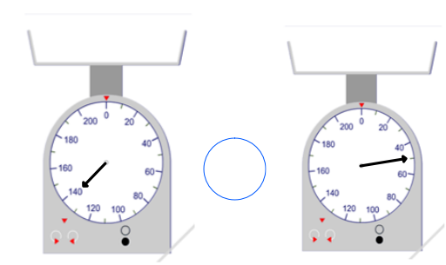
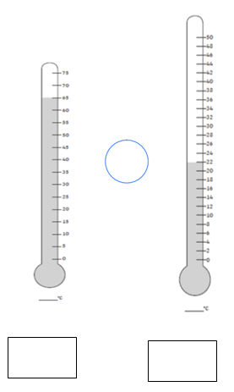
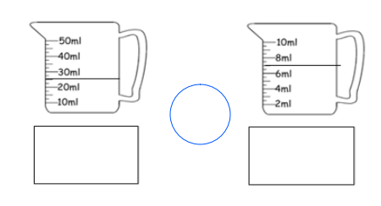

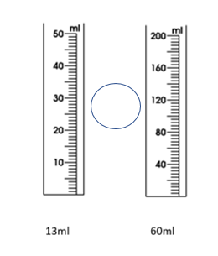
Now draw on these scales to show the correct amounts. Then add a greater than (>) or less than (<) symbol to show which scale shows the largest amount. (Extra Challenge – can you work out the difference between each of the amounts?)

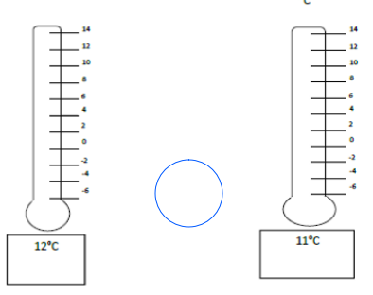
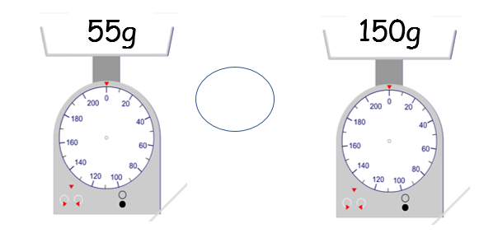
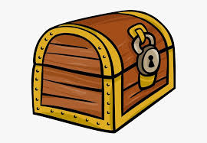
Task 3 – CHALLENGE TIME!
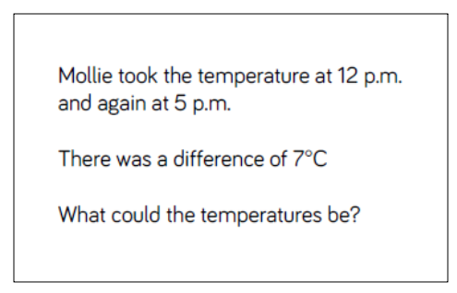
Choose one (or more) of the challenges below.

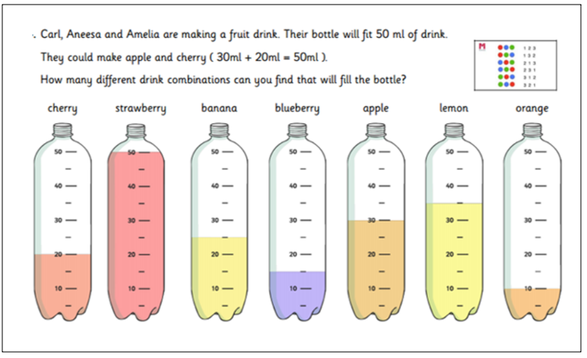

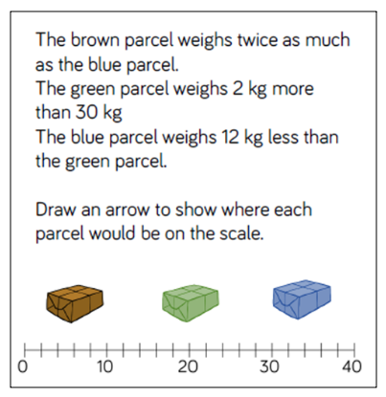

FINAL CHALLENGE – If you have some weighing scales, what is the heaviest item you can find in your house? What is the lightest item you can find in your house? Send in a picture and let’s see who can find the heaviest / lightest objects in the whole of year 2!

