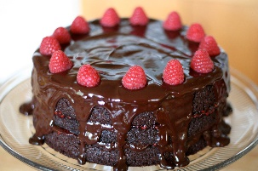
Half term Homework W/C 25.5.2020

Cake and a Natter

This half term we would like you to make a cake or buns with your family and write down the recipe. Please take pictures.

Then once the cake is made, please sit down as a family and enjoy the cake, spend some time having a chat and send us a picture of you all sharing your delicious treats and conversation together. This is about spending quality time as a family together.

I will definitely will be doing this as it is my son Adam’s 14th birthday this Tuesday!

Please send your recipes and photos to:
deputy@dobcroft-inf.sheffield.sch.uk

#mentalhealthweek
