Summer Term 1: Week 5
Maths Task 4 – solving time investigations

- Miss Hughes goes to the supermarket at 2 ‘o’ clock. She spends 1 hour there.  What time does Miss Hughes leave the supermarket? | - Miss Minors goes to sleep at half past 9. She sleeps for 1 hour and a half.  What time does she wake up? | - Mrs Holmes goes for a run around Ecclesall Woods at quarter to 4. She runs for 4 hours.  What time does she finish?
- Mrs Machin has been working on her computer for 2 and a quarter hours. She finishes her work at 5 o’clock.  What time did she start? | - Miss Shaw read a book for 20 minutes, Mrs Peersman read a book for 1 hour and Miss Mather read a book for 45 minutes.  Who read for the longest? | - It takes Miss Culshaw 50 minutes to drive to work. She arrives at 7 o’ clock.  What time did she leave her house?

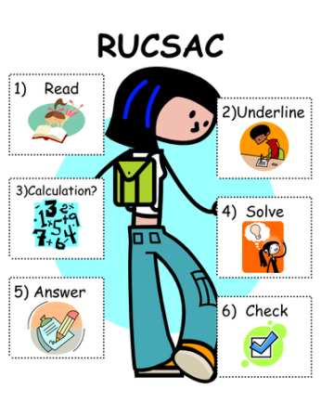

Challenge!
What would you do?
How could you fill your time if you finish your schoolwork at half past 3 and need to be ready for family games night at half past 6? (3 hours = 180 minutes)
Below are some activities and their length of time. You always have to tidy your bedroom and eat your dinner. Which other activities could you also fit into her evening?
How many different combinations can you think of?
Tidy your bedroom  30 minutes | Dinner  25 minutes | Reading  1 hour 30 minutes | Video call family  45 minutes
Football in the garden  1 hour and 10 minutes | Drawing  55 minutes | Watching TV  1 hour 5 minutes | Play with toys  1 hour

