Summer Term 1: Week 5
Maths Task 1 – months of the year and days of the week

I can’t believe that for most of us, our last day in school was nearly 2 months ago! Miss Hughes was wishing one of her friends a “Happy Birthday” last week, and she was thinking how a lot of her friends and family have birthdays in November or September (hers included!)

For maths this week, we’re going to be looking at ordering the months of the year and days of the week, telling time on an analogue clock and solving problem involving time.

To start us off, listen to this catchy song telling us the months of the year in order:
https://learnenglishkids.britishcouncil.org/songs/time-another-year

Can you make a list of the months of the year in order and write on important dates?
This might be your family’s birthdays, the month you started school, the month you lost a tooth or the month you started a new club.
Not every month has the same number of days. Can you find out which months have 31 days, which have 30 and which have 28 or 29? (You can use the GoNoodle ‘guacamole’ song to help with this!)
Add this information onto your list of months.

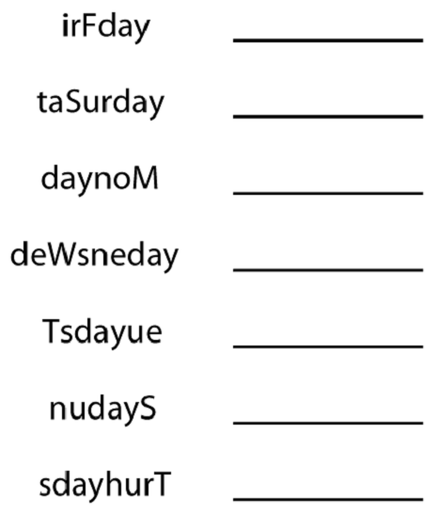
Can you solve this days of the week scramble?
Hint! Days of the week each start with a capital letter.
When you’re writing your diary for your English, check you have spelt every day of the week correctly.

You could also watch this video to help you remember the days of the week in order:
https://www.bbc.co.uk/teach/supermovers/ks1-english-days-of-the-week/zd8njhv

