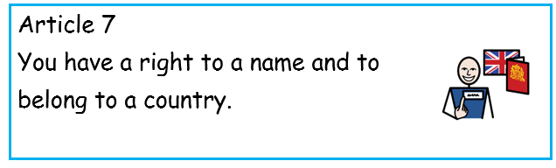
Summer Term 1: Week 5
Sports challenge

Can you write your own name challenge? Think of an activity for every letter. You can repeat the activity with a different number of reps to help!
A 5 star jumps | N 10 burpees
B Touch the floor 5 times | O Throw and catch a ball 10 times
C 5 spotty dogs | P Touch the floor 10 times
D Run 1 lap of the garden | Q 10 tuck jumps
E 5 burpees | R Throw and catch a ball 15 times
F Throw and catch a ball 5 times | S 10 star jumps
G 5 tuck jumps | T High knees for 10 seconds
H Touch the floor 15 times | U Run 2 laps of the garden
I Run on the spot for 10 seconds | V Run on the spot for 20 seconds
J Run 3 laps of the garden | W 15 spotty dogs
K 10 spotty dogs | X 15 burpees
L 15 star jumps | Y High knees for 20 seconds
M DO THE MACARENA! | Z Run on the spot for 30 seconds

Can you create your own alphabet challenge for your family?

