Summer Term 1: Week 5
English – Activity 3
Today we are going to be thinking about one of our favourite SPaG features……conjunctions! We have done these lots and lots in class so let’s see what you can remember.
There are two types of conjunctions – co-ordinating conjunctions and subordinating conjunctions.

Can you remember all of the co-ordinating conjunctions? Cover them over and practise saying them out loud. Do this a few times until you can say them all without looking!
and or so but yet
Can you remember all of the subordinating conjunctions? Cover them over and practise saying them out loud. Do this a few times until you can say them all without looking!
that when if because as

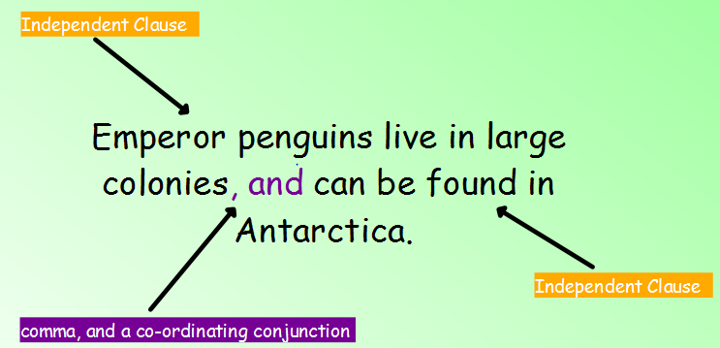
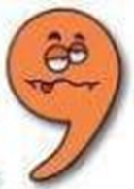
Here are some examples of how we can use co-ordinating conjunctions and subordinating conjunctions correctly in our writing.
Don’t forget your comma comes before your co-ordinating conjunction
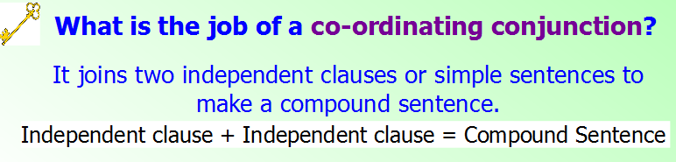

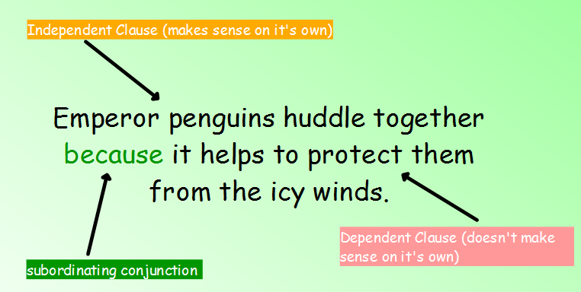
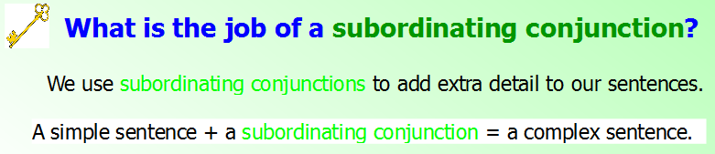
Going Deeper (if you want to!)
A subordinating conjunction can also be placed at the beginning of the sentence. We then write the dependent clause, add a comma and then finish with the independent clause. Like this:
Because it helps to protect them from the icy winds, emperor penguins huddle together.

Now it’s your turn. Look at the sentences below and put in a co-ordinating or subordinating conjunction (and punctuation) to make this sentence correct. Then circle whether it is a compound or complex sentence.

The sun was shining ____________ the children decided to play in the garden. Compound/Complex

The boy was excited _________________ tomorrow was his birthday. Compound / Complex

The dog barked loudly ____________________ the doorbell rang. Compound / Complex

I will go for a run ______________ I will go for a cycle today. Compound / Complex

Now let’s see if you can write your own sentences!
- Write one sentence about your day that has a co-ordinating conjunction in it.
- Write one sentence about your day that has a subordinating conjunction in it.

CHALLENGE!
Can you incorporate either a co-ordinating or subordinating (or both) into today’s diary extract? Underline it in purple or green to show what you have used!

