Summer Term 1: Week 5
English – Activity 2
Today we are going to be thinking about the different word classes – noun, verb, adjective and adverb.
Can you match up the word class name to its correct definition?
Noun A word that describes what an action, occurrence or state of being.
Verb A word that describes a verb.
Adjective A person, place, thing or idea.
Adverb A describing word.
adjectives | nouns | 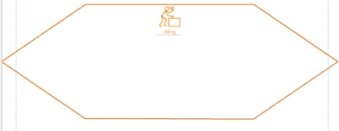  verbs | adverbs
beautiful | table | jump | quickly

Can you think of 3 examples of each word class to fit into the table? We have already given you an example of each.

Can you think of a suitable adjective to fit into the gap in this sentence?
The dog ran excitedly across the field.

Can you think of a suitable verb to fit into the gap in this sentence?
The children a beautiful picture.

Can you think of a suitable noun to fit into the gap in this sentence?
The terrifying chased its prey.

Can you think of a suitable adverb to fit into the gap in this sentence?
The ice cream melted in the sun.

CHALLENGE!
How many of these different word classes can you put into today’s diary entry? Underline them in the colours used above to show what you have managed to include!

